1. We first created the Zod validator schemas

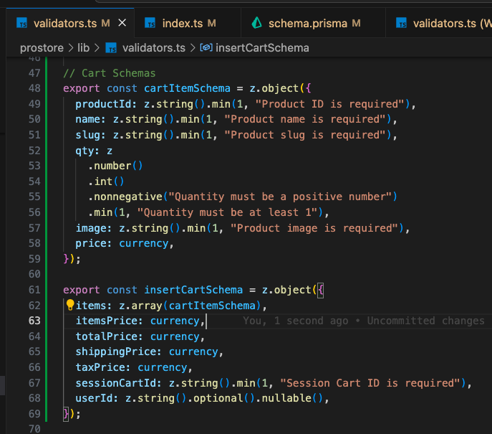

1. Then we imported them in our types for later use

1. Then we made the Prisma model

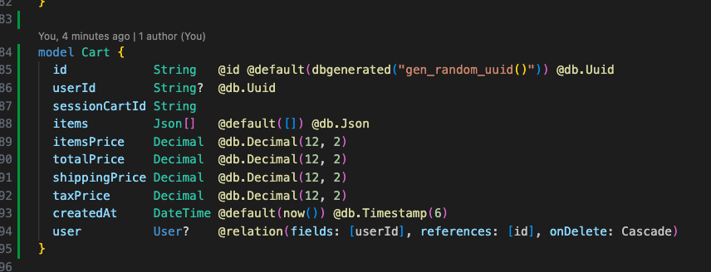

1. Make sure Cart exist in the user mode
2. Then we run the Prisma client generation command

1. Then we ran the migrations

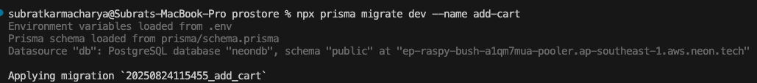

1. And lastly, we checked everything in the Prisma studio



